

**American International University- Bangladesh**

**CSC 3222: Web Technologies**

**CO1.1 and CO2.1 Evaluation**

**Project Report**

**Spring 19-20**

**Project Title:Event Management System**

**Section: F**

|  |  |
| --- | --- |
| Student Name | Student Id |
| Nahid,Nafiz Ahamed | **17-34682-2** |
| S. M. Estiaq Ahamed | **17-33972-1** |
| Rahikul Zannat | **17-33962-1** |
| Pobitra paul | **17-33965-1** |

**Introduction:**

*In this digital world everything is online based.Nowadays online event management doing a good jobs where we can find every information and experts for arranging a event.So we choose to do project on this.*

**Background Study**

*We have used couple of website and take idea for building this project-*

1. *GitHub*
2. *W3schools*

**Requirement Analysis:**

1. **User Category:**

There are 4-types of Users here. They are:

* Admin
* Manager
* Photographer
* Catering Manager

1. **Feature List:**

In this project the “**Admin**” has the following features:

1. Add employee

2. Remove employee

3. Edit employee profile

4.check profile information

5.Manage projects

6.Add photographer

7.Remove photographer

8.Manupulate information for all users

9.Login(common)

10.Admin register(common)

11.Manipulate admin profile(common)

12.Add catering employee

13.Block users

14. Salary information

15.customer information

16.edit user

In this project the “**Manager**” has the following features:

1.Offer Different kind of events.

2.Show the variety of theme in projects.

3.Inform the costing and discount on events.

4.Suggest different Hall for booking.

5.Able to show booked hall.

6.Provide package on function arrangement.

7.Can add function and event.

8. Can remove function and event.

9. Able to see the employee list.

10. Can add employee .

11.Can remove employee..

11. Can contact with Admin of the system

12.Able to see the assign list of employee on project.

13. Login(common)

14.Manipulate Project information(common)

15. Register (common)

In this project the “**Catering**” has the following features:

1.Add food items,

2.Remove food item,

3.Add food price,

4.Manage food price,

5.Add chefs’ profile,

6.Remove chefs’ profile,

7.Login(common)

8.Catering register,

9.Manage catering profile,

10.Food cart,

11.Why us,

12.Stricking features,

13.Offers,

14.Packages.

15.Hot line

16.Register(common)

17.Manipulate Profile(common)

In this project the “**Photography**” has the following features:

**Design:**

Draw an entity diagram of your project here.

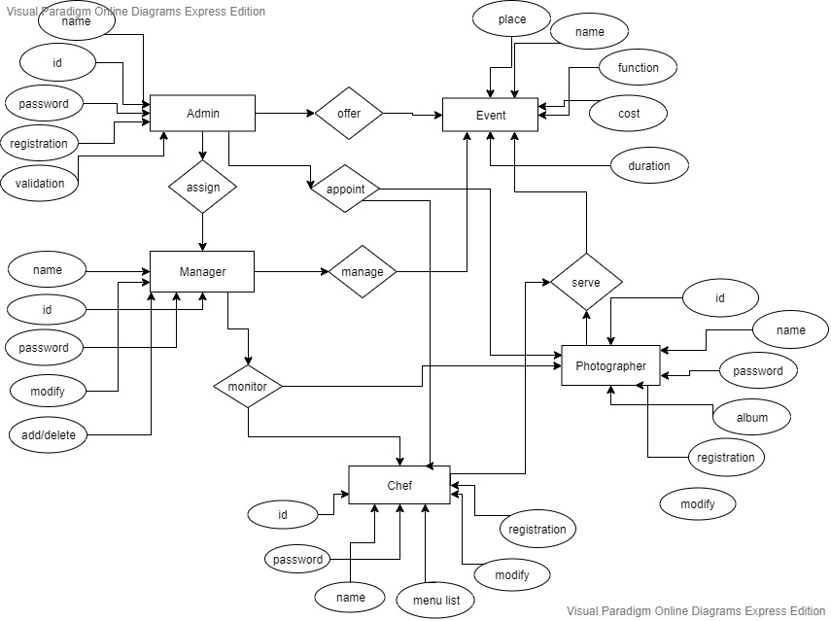

**Tools Used:**

To develop this project, we have used the following:

1. *GitHub*
2. *W3schools*
3. *Notepad++*
4. *SublimeText*
5. *Visual-paradigm(ER-diagram)*

**System Images against the Specification:**

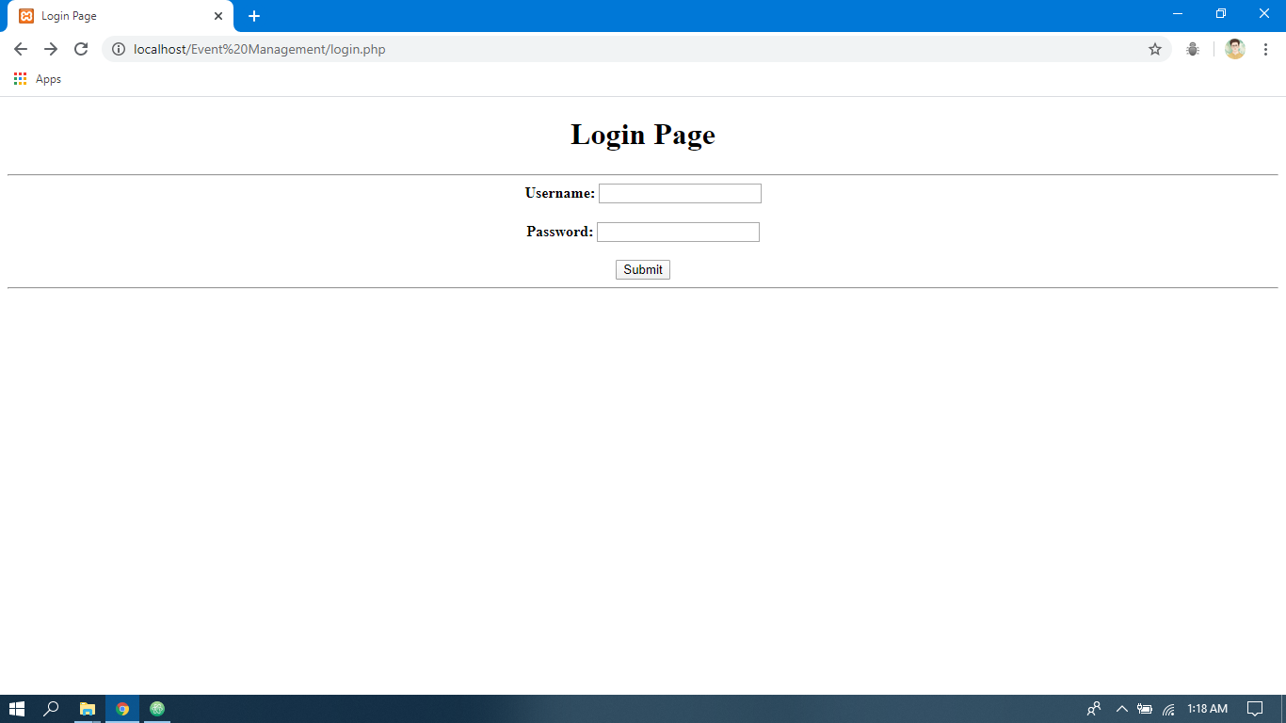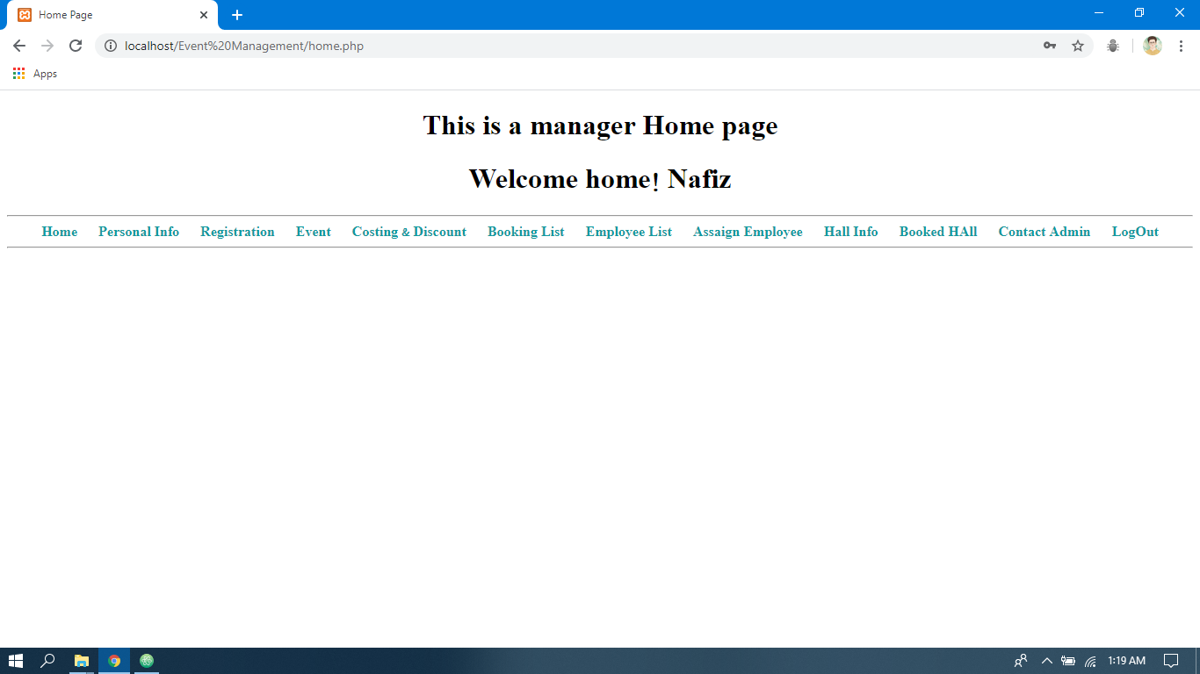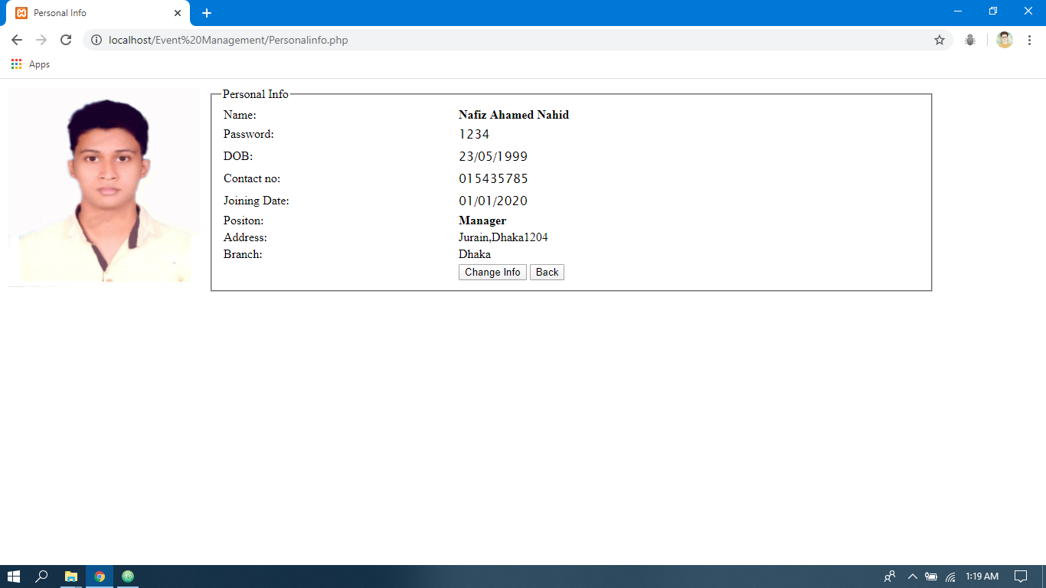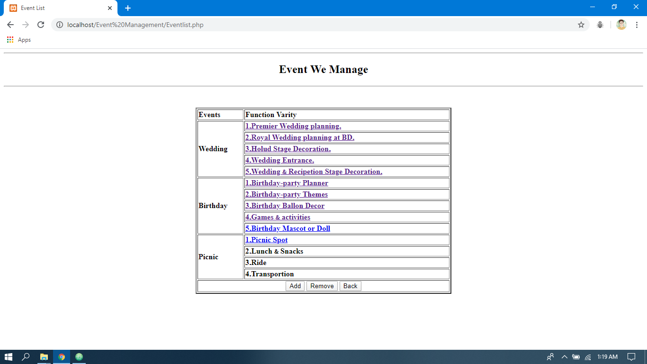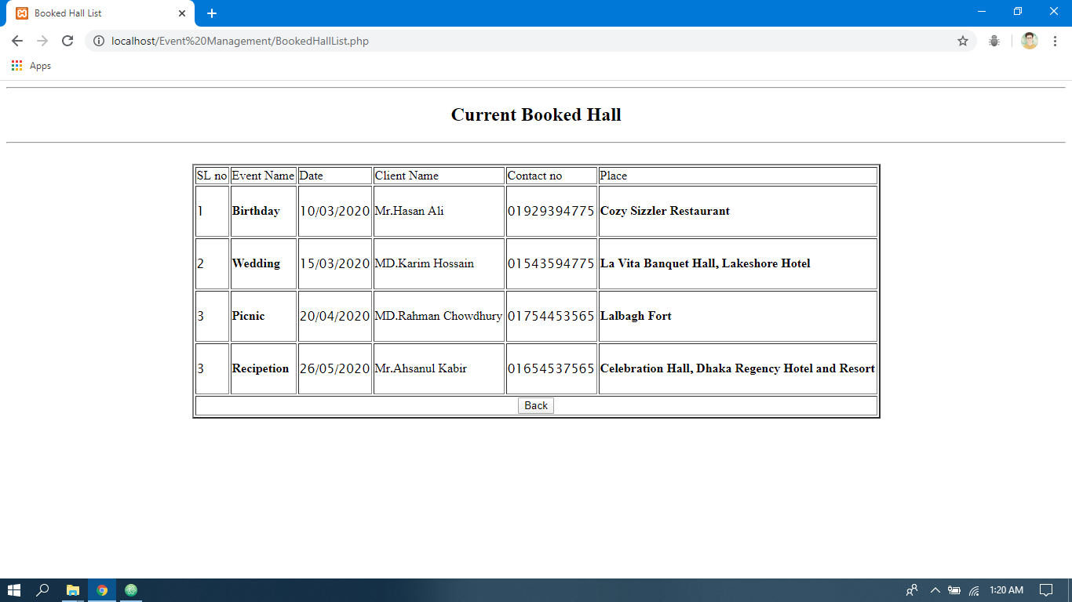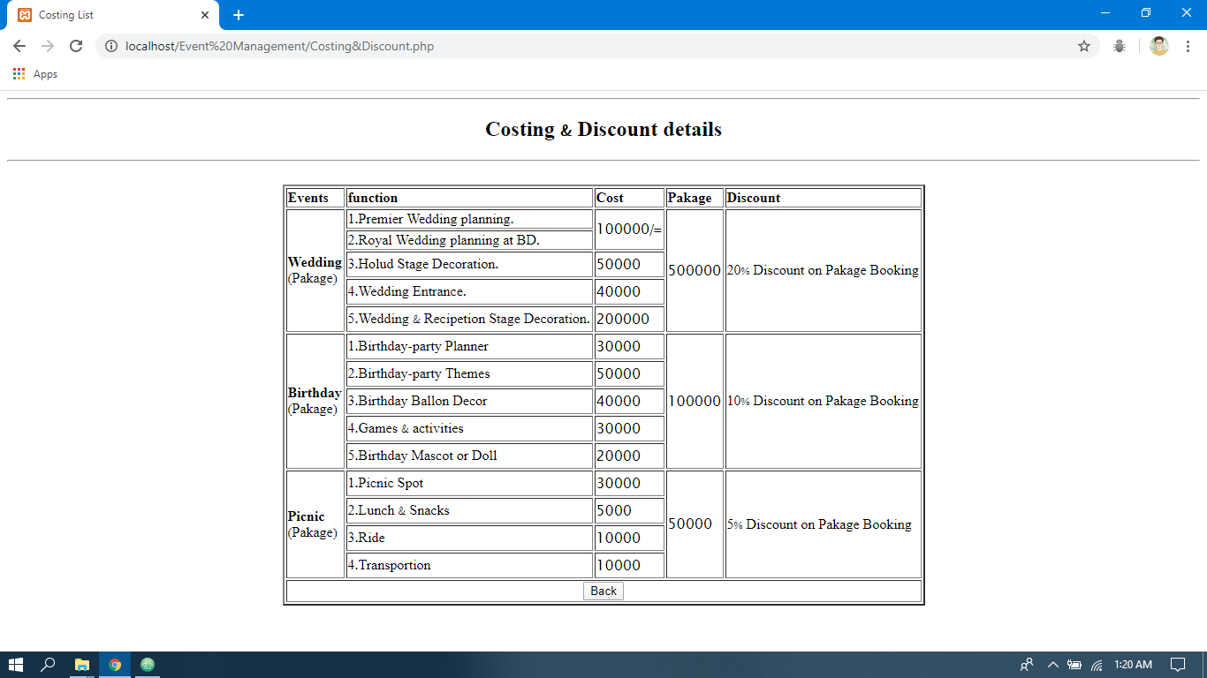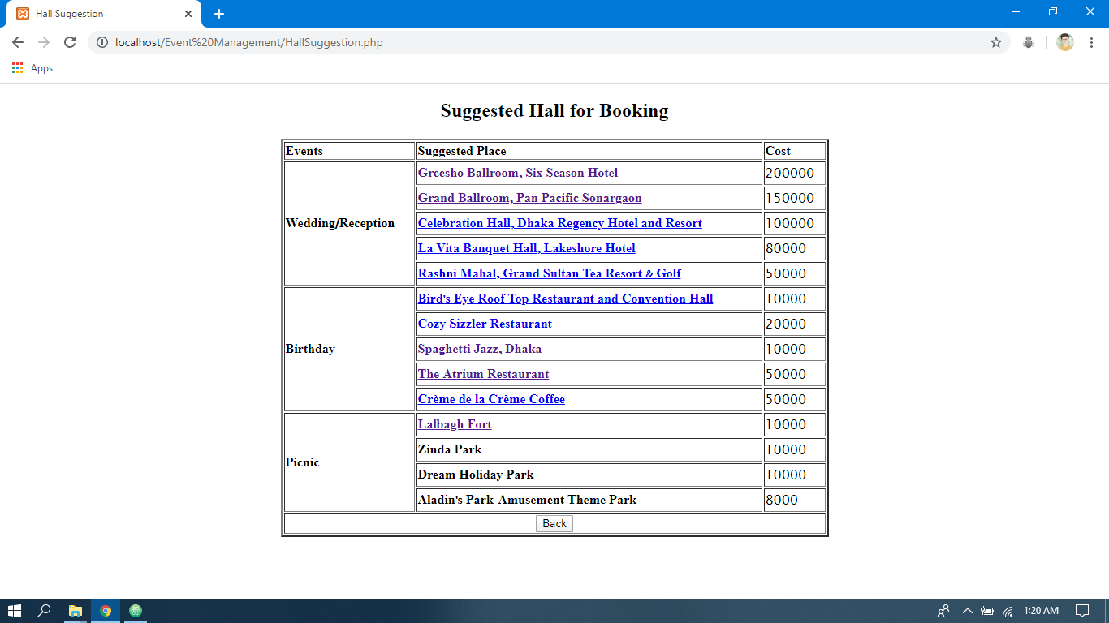

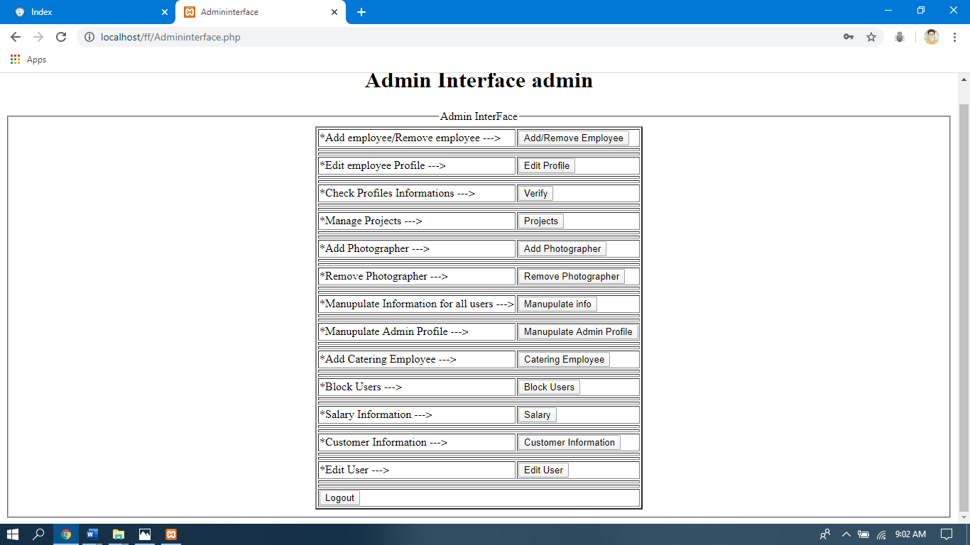

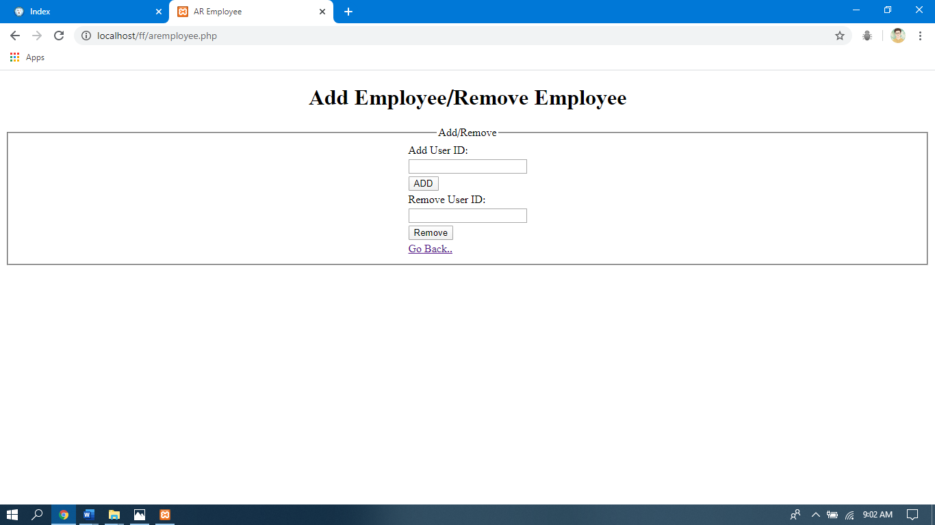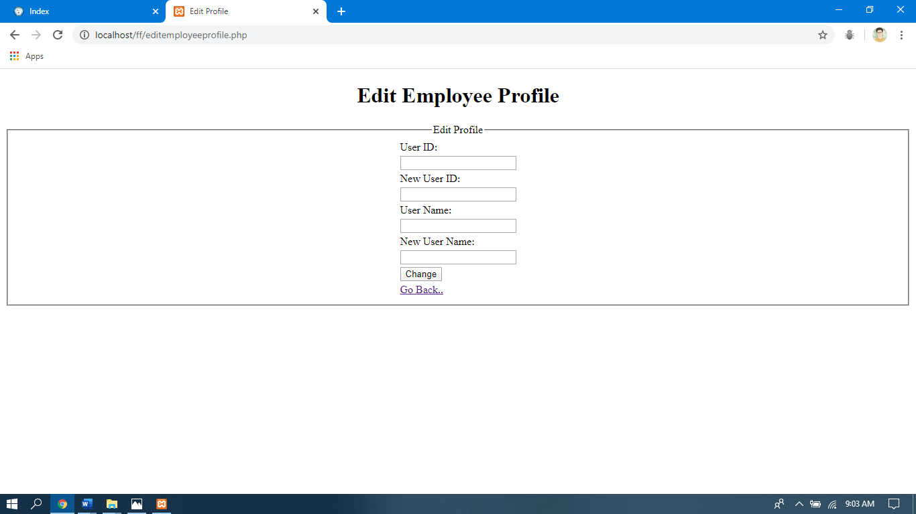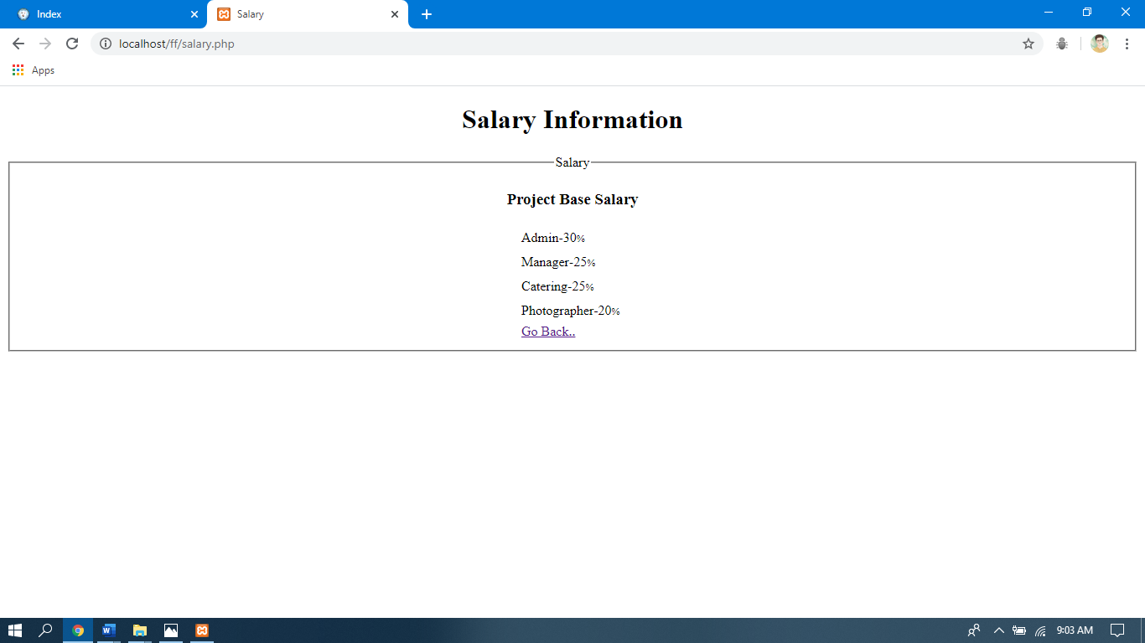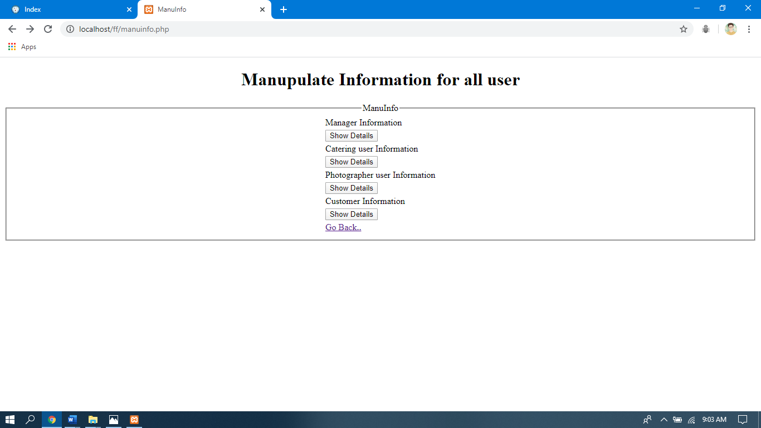

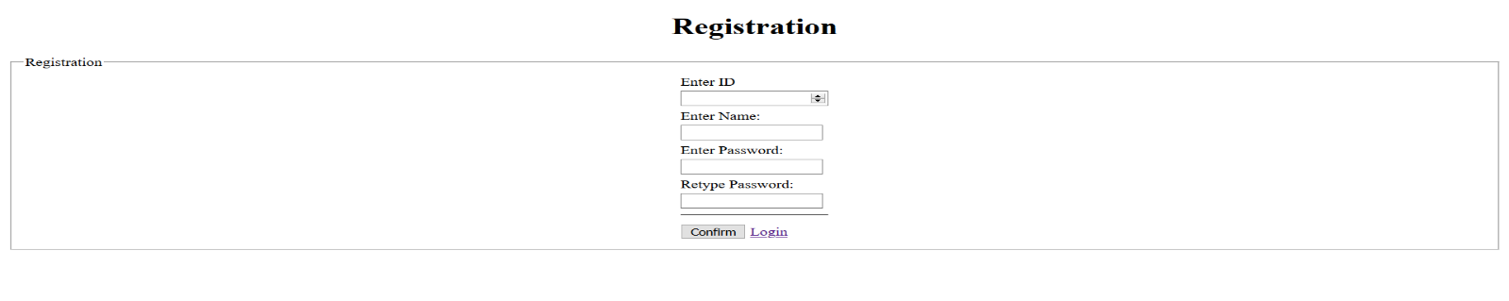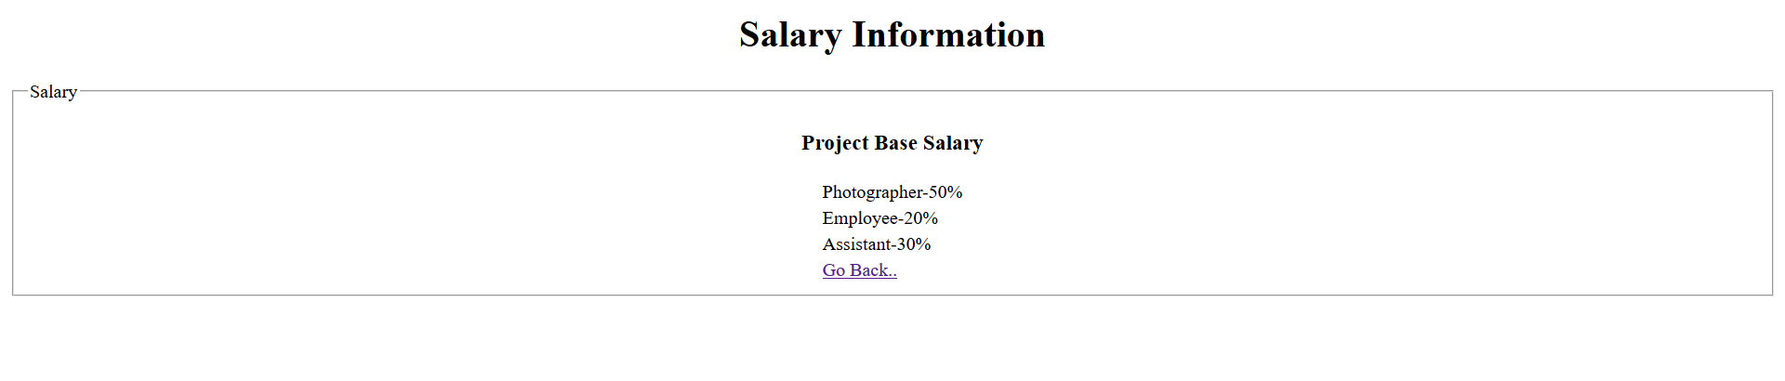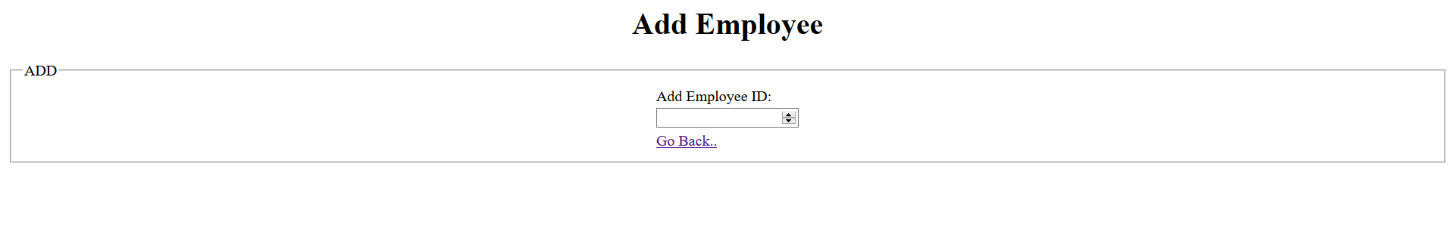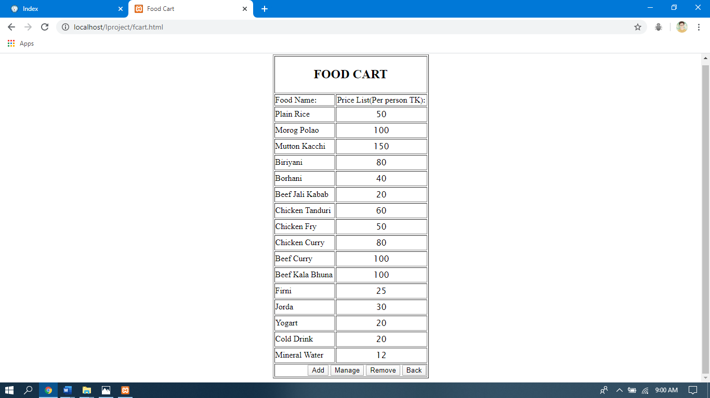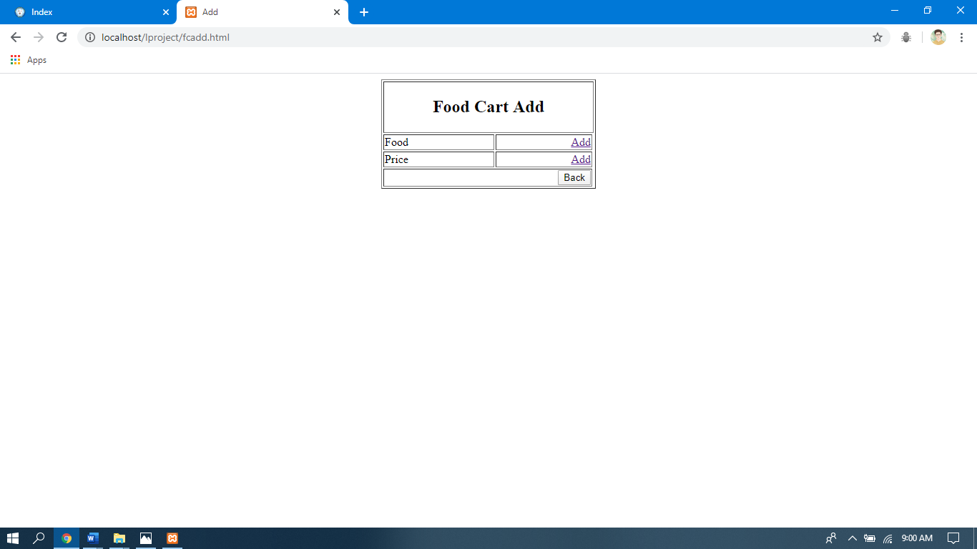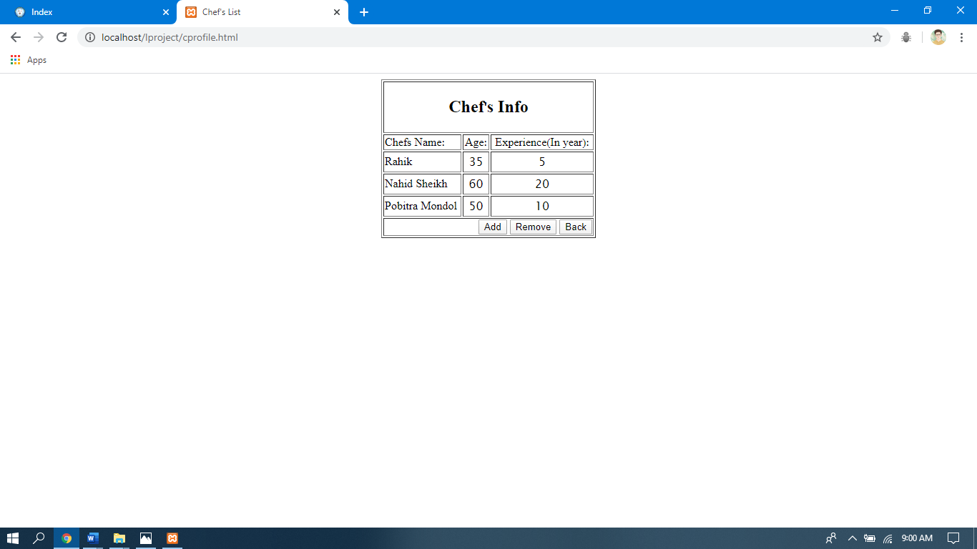

**Impact of this Project:**

This digital world is internet oriented.Every Management system are going to internet based.So for the event management it is going very popular to go on Internet.So there is a vey good future for this project.

**Limitations and Possible Future Improvements:**

We do not have use database for this project.So we can not store the information permanently.The whole user part are not integrated yet so Admin & Manager cannot see the other profile.

|  |  |  |  |  |  |
| --- | --- | --- | --- | --- | --- |
| **CO1.1 and CO2.1 Evaluation: Project Report Evaluation** | | | | | |
| **Project Proposal**  **(5)** | **Background**  **Study**  **(5)** | **Requirement Analysis**  **(5)** | **Entity**  **Diagram**  **(5)** | **System Images**  **against the**  **Specification (5)** | **Total (25)** |
|  |  |  |  |  |  |
|  | | | | | |